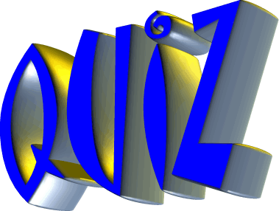

Q1. What do you wear on your bike to protect your head if you fall off?

Q2. What can you ring on your bike to let others know you are there?

Q3. What is the name of the smaller bikes without pedals and stabilisers that Mini Wheelers use?

Q4. How many riders can fit on a TANDEM BIKE?

Q5. Which handlebar is your front brake on?
Is it… Right hand Left hand

Q6. Unscramble the letters to find the hidden cycling words.
ACHIN
LADSEP
HEELSW

Q7. What does this sign mean?
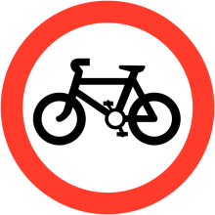

Is it….. Cycles Only No cycling Cycle route ahead

